6th International Symposium on

Animal Mortality Management Amarillo, Texas June 3-7, 2018

EMERGENCY RESPONSE: COMPOSTING IN A

BRUCELLOSIS SUIS OUTBREAK

## Jean Bonhotal, Senior Extension Associate, Director CWMI

Cornell Waste Management Institute, [http://cwmi.css.cornell.edu,](http://cwmi.css.cornell.edu/) [jb29@cornell.edu](mailto:jb29@cornell.edu)

## Written for presentation at the

**6th International Symposium on Animal Mortality Management Amarillo, Texas**

## Embassy Suites Hotel and Conference Center

**Abstract. Emergency Response: Composting in a Brucellosis suis Outbreak**

*A Brucellosis suis outbreak was identified in early August 2016 on several small non-industrial farm in northeastern New York State. The disease was identified because a farmer became ill from the bacterium* ***Brucellosis suis.*** The team of state veterinarians, an APHIS veterinarian and disposal people visited the largest affected farm to assess whether the pigs could be disposed of on the farm. There were a few places that could be used for composting however the farm was very wet and there were no staging areas to dispatch the pigs. The farms were also under a lot of stress with the outbreak and eventual loss of their pigs. In the end it was determined that the pigs should be hauled away from the farm, dispatched and composted.

**Keywords.** Brucellosis suis, disease outbreak, mortality composting, disposal.

The authors are solely responsible for the content of this technical presentation. The technical presentation does not necessarily reflect the official position of the Sponsoring Agencies and its printing and distribution does not constitute an endorsement of views which may be

expressed. Technical presentations are not subject to the formal peer review process; therefore, they are not to be presented as refereed publications. Citation of this work should state that it is from an International Symposium meeting paper. EXAMPLE: Author's Last Name, Initials. 2018. Title of Presentation. 6th International Symposium on Animal Mortality Management, Amarillo Texas. For information about securing permission to reprint or reproduce a technical presentation, please contact Gary Flory (Gary.Flory@deq.virginia.gov) or Mark King (Mark.A.King@maine.gov).

In early August 2016, a Brucellosis suis outbreak was identified on several small non- industrial farms in northeastern New York State. The disease was identified because a farmer became ill from the bacterium **Brucellosis suis,** which was transmitted by the farms pigs.

Determining the area of the outbreak: The first batch of pigs were confirmed and disposed of at Cornell School of Veterinary Medicine in an alkaline digester. The NYS and APHIS vets assessed farms in the area to see how far the disease spread. As a number of farms surfaced with the disease the veterinarians checked to see if any of the pigs on the infected farms were recently sold or loaned to other farms. It was determined that a male intended for breeding had been sent to a farm in southern Maine. It had not been integrated into the herd so that pig was dispatched and composted in Maine.

A team of state veterinarians, an APHIS veterinarian and disposal people visited the largest affected farm to assess whether the pigs could be disposed of on the farm. At the beginning of the outbreak, pigs were being sent for rendering, however rendering company decided that they did not want to accept pigs that were associated with the outbreak and rejected the rest. There were a few locations that could be used for composting, however the farm was very wet and there was no staging area to dispatch the pigs. It was far to wet to consider burial. The farm was also under a lot of stress with the outbreak and eventual loss of their pigs, it would have been very traumatic to dispose of on farm. In the end it was determined that the pigs should be hauled away from the farm, dispatched and composted.

There was a farmer in the area that had experience composting livestock over the years, had equipment and was not raising pigs or other animals that could contract the disease. At this point it was late August, it was county fair time and it was hot. It was difficult to get haulers to transport animals because of the fair but transport trailers were hired after the fair activities and a team of vets from Massachusetts to Georgia were brought in to kill the animals and collect tissue samples, equipment and carbonaceous bulking material were secured. Eighty-five percent of the animals were dispatched by captive bolt, Piglets were chemically euthanized on the farms and transported to the compost site. Most animals were integrated into the windrow within minutes, piglets with in hours. Interesting note: There were few vets with experience using captive bolt and the vets that did have experience gained it from experience working in slaughterhouses. It was not common to find the captive bolt implement.

The site chosen on the farm was very protected by vegetation, .75 miles off a county road and away from the main farm. It was a location where dairy bedding was being stockpiled. Woodchips from a municipal landfill were trucked to the site. In this case, the chips were free but had to be conveyed about 100 miles to the site. Trucking was about

$1000.00.

The processing of the animals occurred at two different times, August 17/18 and September 7. Containment was built and of the 270 pigs processed only one escaped for about 4 hectic minutes. A bed of woodchip 10 feet wide by 50 feet long and 20 inches deep was built on the soil pad. After each animal was dispatched it was conveyed to the pile with a leg chain attached to the bucket of a loader. Pigs generally have a higher percentage of body fat, so it is important to ensure that there is enough chunky,

absorbent carbon to allow air to circulate around the animals and absorb the excess fat.

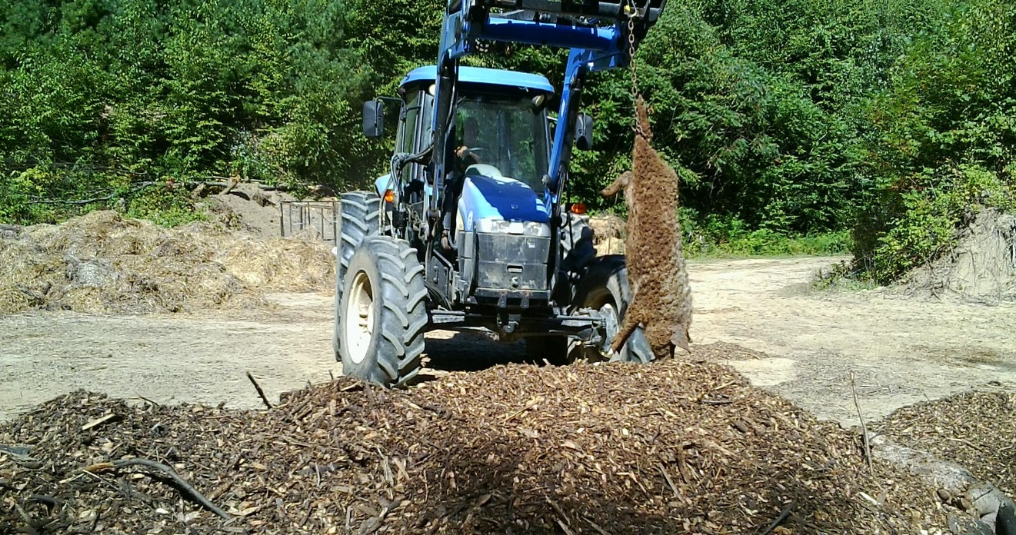

Dead pigs were conveyed with a loader and placed in the second layer of the windrow.

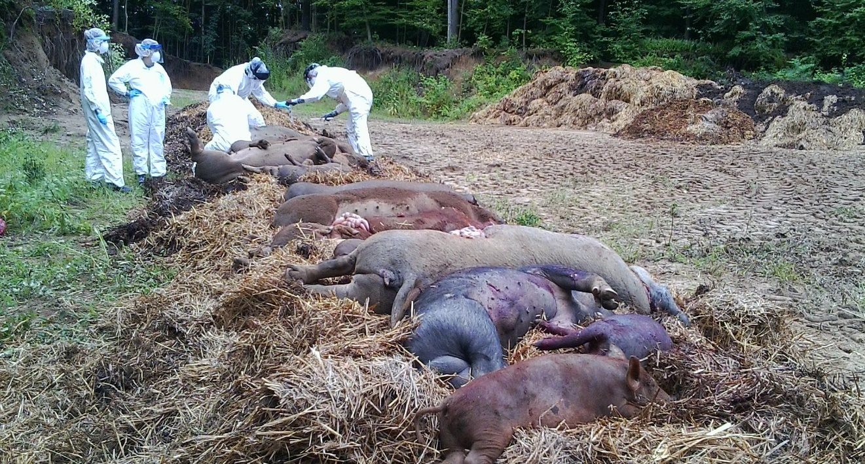

Tissue samples were taken from animals to assess the extent of infection

The animals were positioned in the piles, tissue samples were taken and a layer of carbon was placed over the dead stock. In the case of these pigs ranging from 2 to 1000 pounds, two layers of pigs could be stacked in the pile with carbon placed between the layers. If there were very large pigs on the bottom layer smaller pigs would be positioned on the next layer. The first layer had most of the large pigs because they are harder to

lift to a second layer. In the first build, there was a shortage of woodchips because of truck timing however, there was a large stockpile of dairy bedding mixed with manure. There was a good woodchip base where dead pigs were placed, and then woodchips were combined with bedding material for the second layer and overall cap. In the end, the two windrow dimensions were 13’ wide x 6.5’ tall x 65’ long.

Temperatures were monitored to ensure that thermophilic temperatures above 133 degrees F were reached throughout the windrows.

|  |  |  |  |  |  |  |  |  |  |  |  |  |  |
| --- | --- | --- | --- | --- | --- | --- | --- | --- | --- | --- | --- | --- | --- |
| **Pigs** | | | | | | | | | | | | | |
| Day/Date |  | 1 | 2 | 3 | 4 | 5 | 6 | 8 | 10 | 12 | 14 | 9/28 | 10/ 12 |
|  |  |  |  |  |  |  |  |  |  |  |  |  |  |
| Temp | 18” | 95 | 120 | 135 | 133 | 138 | 140 | 142 | 145 | 150 | 154 | 145 | 115 |
| WR-1 | 36” | 98 | 122 | 138 | 138 | 142 | 145 | 130 | 140 | 143 | 156 | 148 | 120 |
| 8/18-19 |  |  |  |  |  |  |  |  |  |  |  |  |  |
| WR-2 | 18” | 97 | 125 | 133 | 135 | 139 | 140 | 152 | 152 | 152 | 150 | 150 | 148 |
| 9/7 | 36” | 99 | 133 | 140 | 142 | 142 | 145 | 158 | 155 | 152 | 160 | 149 | 148 |
|  |  |  |  |  |  |  |  |  |  |  |  |  |  |

**Ambient -95 F on 9/7 Opened pile on 12/7 ambient 30 F**

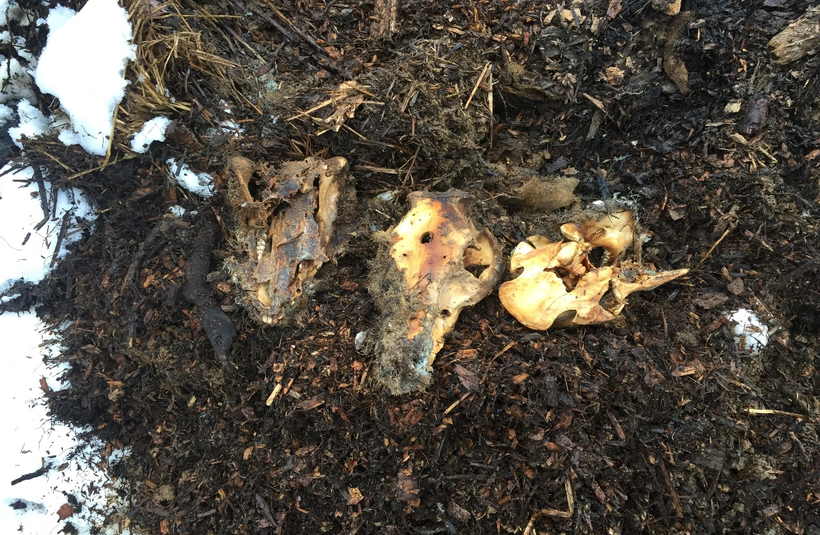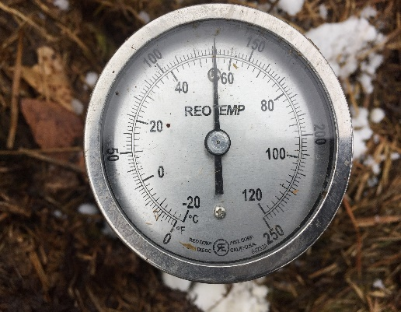

Cornell Waste Management Institute

9/7 -12/7 : Temps above 56 C in spots, bones and some hide remain. Very little discernable soft tissues left.

**Conclusions**

The windrows were closed and the medium was left to finish the composting process, curing occurred throughout the winter. The compost process was successful in managing the Brucellous suis. Temperatures were monitored and recorded and indicated that temperatures needed to disinfect were met. After three months, soft tissue was gone; bone, teeth and some hide remained. Bones from young pigs disappeared while bones from mature pigs persisted. After the 3-month assessment, the windrows were left to finish the curing process. If the windrow is properly built with good natural air circulation, windrows can be, disinfected in as little as 7 days depending on the size of the animals and the targeted disease. There is still too much flesh in piles to really turn or move them. With livestock such as pig, it is not wise to move the windrow for about 3 months or when most of the flesh has been digested. It takes 9 months to complete the compost process in static windrows. Large bones can then be removed before land spreading.

# References

Miller, Lori, et al. 2016. Mortality Composting Protocol for Avian Influenza Infected Flocks – FY2016 HPAI Response. USDA APHIS, 1-31.

Schwarz, M., and Bonhotal, J. 2015. Effectiveness of Composting as a Means of Emergency Disposal: A Literature Review. 5th International Symposium on Managing Animal Mortality, Products, By Products. Lancaster PA.

Schwarz, M., Bonhotal, J. and Rozeboom, D. 2010. The Space It Takes-Footprint Calculator for Composting Butcher Waste. Cornell Waste Management Institute, 1-8.

Bonhotal, J., Telega, S.L., and Petzen, J.S. 2002. Natural Rendering: Composting Livestock Mortality & Butcher Waste, Cornell Waste Management Institute.12 page fact sheet and 3 posters.